

**COPOM INDUSTRIAL TRAINING**

**& EDUCATION SERVICES**

**BN: 3430864**

**COPOM INDUSTRIAL TRAINING & EDUCATION SERVICES (CITES)**

COPOM Industrial Training Centre is a learning and development (L&D) centre with a unique difference and unparalled performance standards to up-skill your workforce for unbeatable productivity.

Let’s make your Talent Management Processes seamless and effective with our

World Class time-tested, industry-best practice-centered

learning and development (L&D) programmes.

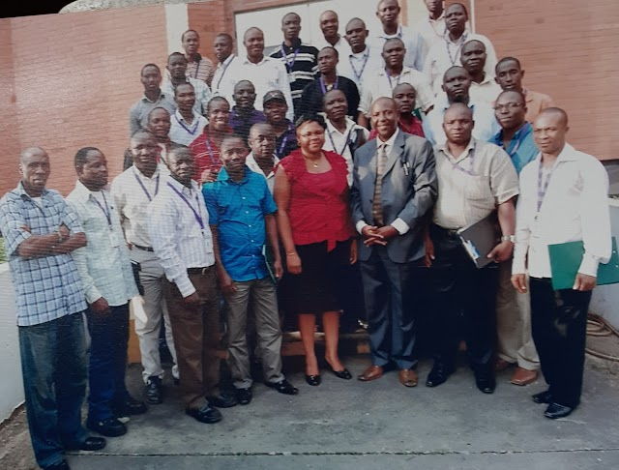

***CITES …. Cutting edge industrial training***

CITES is led by a team of consulting engineers, technologists, scientists and industrial management experts with proven competencies and experience in industrial training for executives, technical specialists, artisans and factory workers across varied industrial sectors nationwide.

COPOM Industrial Training Centre offers you high quality, low cost, value for money staff training with great post-learning performance assurance, whether you want to improve safety, quality, maintenance reliability, production line efficiency, store/ warehouse operations, utilities, team building or supervisory and industrial management skills, COPOM is your best-bet to optimize your training interventions.



***Contact us:***

***The Head, Training & Development***

***COPOM INDUSTRIAL TRAINING & EDUCATION SERVICES***

***Acme House, 3rd Floor, 23 Acme Road, Ogba Industrial Estate, Ikeja Lagos.***

***Tel: 08066411565, 09023194157, 08023140750, 08069006671***



**COPOM INDUSTRIAL TRAINING & EDUCATION SERVICES**

**2022 CALENDAR**

|  |  |  |  |  |
| --- | --- | --- | --- | --- |
| **CODE** | **TITLE OF COURSE** | **FOR WHOM** | **DATE** | **FEES (N)** |
| CITES 01 | IMPROVEMENT COURSE FOR FACTORY OPERATIVES | Factory Machine Operators, Production Workers | Feb 01  Apr 04 | 30,000  5-6 Participants (150,000) |
| CITES 02 | CURRENT GOOD MANUFACTURING PRACTICE (cGMP) COURSE | Production, Quality, Maintenance Warehouse Staff | Feb 03  June 23 | 35,000  5-6 Participants  (175,000) |
| CITES 03 | PRODUCTIVITY IMPROVEMENT, TIME MANAGEMENT & IMPROVED WORK ATTITUDE COURSE | All Staff | Feb 03  June 08 | 35,000  5-6 Participant  (175,000) |
| CITES 04 | HEALTH & SAFETY AT WORK | All Staff | Mar 07  May 16 | 35,000  5-6 participant  (175,000) |
| CITES 05 | FORKLIFT DRIVING & MATERIALS HANDLING COURSE | Forklift Drivers, Stores/ Warehouse Personnel | Feb 01  Apr 04 | 37,000  5-6 Participant  (185,000) |
| CITES 06 | HYGIENE, SANITATION & GOOD HOUSEKEEPING COURSE | All Production, Quality, Stores & Allied Factory Staff | Mar 07  May 16 | 37,000  5-6 Participant  (185,000) |
| CITES 07 | 5S/6S TRAINING | All Staff | Mar 07  May 16 | 37,000  5-6 Participant  (185,000) |
| CITES 08 | EFFECTIVE PRODUCTION SUPERVISION COURSE | Production Supervisors & Team Leaders | Apr 20  May 23 | 38,000  5-6 Participant  (190,000) |
| CITES 09 | INNOVATIVE PRODUCTION MANAGEMENT SKILLS COURSE | Production Managers & Senior Supervisors | May 04  May 23 | 39,000  5-6 Participant  (195,000) |
| CITES 10 | MAINTENANCE SKILLS IMPROVEMENT COURSE | Maintenance Supervisors & Technicians | Mar 17 | 38,000  5-6 Participant  (190,000) |
| CITES 11 | STOREKEEPING, WAREHOUSING & MATERIAL HANDLING SKILLS COURSE | Stores/Warehouse Staff | Mar 01  July 25 | 38,000  5-6 Participant  (190,000) |

|  |  |  |  |  |
| --- | --- | --- | --- | --- |
| CITES 12 | QUALITY INSPECTION SKILLS COURSE | Quality Inspectors/QC Staff | Mar 01  Aug 08 | 39,000  5-6 Participant  (195,000) |
| CITES 13 | EFFECTIVE PLANNING SKILLS COURSE | Production/ Maintenance Managers / Supervisors | June 06  Jul 21 | 39,000  5-6 Participant  (195,000) |
| CITES 14 | COMMUNICATION & REPORT WRITING SKILLS | Manager/Supervisors | May 12 | 37,000  5-6 Participant  (185,000) |
| CITES 15 | SECURITY VIGILANCE COURSE | Security Personnel | Mar 28  Jul 19 | 35,000  5-6 Participant  (195,000) |
| CITES 16 | DRIVING & BIKING SKILLS IMPROVEMENT FOR SAFETY COURSE | Drivers & Motorcycle Riders | Feb 21  Jun 14 | 38,000  5-6 Participant  (190,000) |
| CITES 17 | WASTE REDUCTION COURSE | Factory Staff | Apr 28 | 38,000  5-6 Participant  (190,000) |
| CITES 18 | WATER TREATMENT COURSE | Utility Staff | Jul 04 | 39,000  5-6 Participant  (195,000) |
| CITES 19 | CUSTOMER RELATIONS SKILLS COURSE | Customer-Contact Staff | Feb 14  May 16 | 39,000  5-6 Participant  (195,000) |
| CITES 20 | OPERATIONS PLANNING & CONTROL COURSE | Production/ Materials/Maintenance Managers/Supervisors | Jul 22 | 39,000  5-6 Participant  (195,000) |

Please forward your nomination to reach us at least 3 weeks to the date of Training. We organize IN-HOUSE TRAINING to meet your specific Training requirements, including courses not mentioned above.

Thanks.



***Contact us:***

***The Head, Training & Development***

***COPOM INDUSTRIAL TRAINING & EDUCATION SERVICES***

***Acme House, 23 Acme Road, Ogba Industrial Estate, Ikeja Lagos.***

***09023194157,08023140750, 08069006671, 08066411565.***